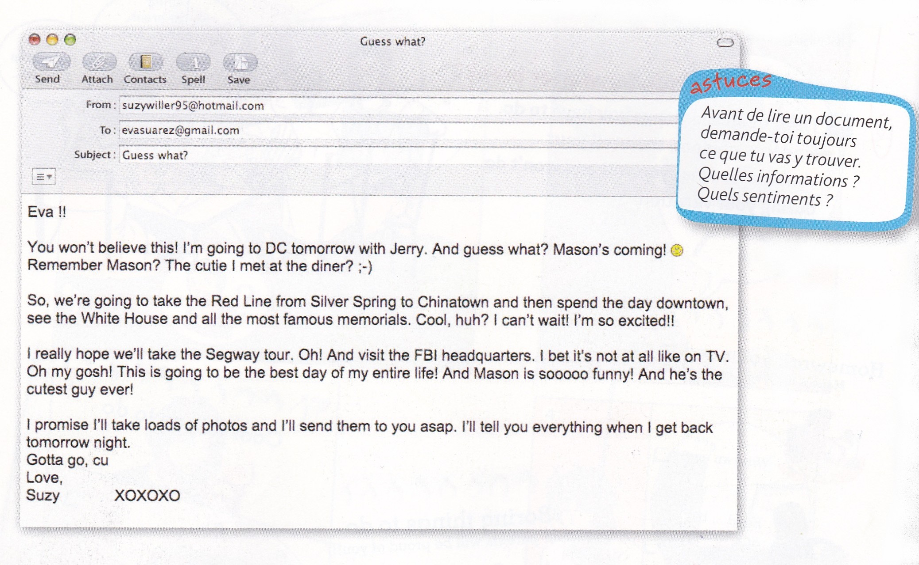

Eva !!
You won't believe this ! I'm going to DC tomorrow with Jerry. And guess what? Mason's coming!
Remember Mason? The cutie I met at the diner? ;-)
So, we're going to take the Red Line from Silver Spring to Chinatown and then spend the day downtown,
see the White House and all the most famous memorials. Cool huh? I can't wait! I'm so excited!!
I really hope we'll take the Segway tour. Oh! And visit the FBI headquarters. I bet it's not at all like on TV.
Oh my gosh! This is going to be the best day of my entire life! And Mason is sooooo funny! And he's the
cutest guy ever!
I promise I'll take loads of photos and I'll send them to you asap. I'll tell you everything when I get back
tomorrow night.
Gotta go, cu
Love,
Suzy XOXOXO

Eva !!
You won't believe this ! I'm going to DC tomorrow with Jerry. And guess what? Mason's coming!
Remember Mason? The cutie I met at the diner? ;-)
So, we're going to take the Red Line from Silver Spring to Chinatown and then spend the day downtown,
see the White House and all the most famous memorials. Cool huh? I can't wait! I'm so excited!!
I really hope we'll take the Segway tour. Oh! And visit the FBI headquarters. I bet it's not at all like on TV.
Oh my gosh! This is going to be the best day of my entire life! And Mason is sooooo funny! And he's the cutest guy ever!
I promise I'll take loads of photos and I'll send them to you asap. I'll tell you everything when I get back tomorrow night.
Gotta go, cu
Love,
Suzy XOXOXO

